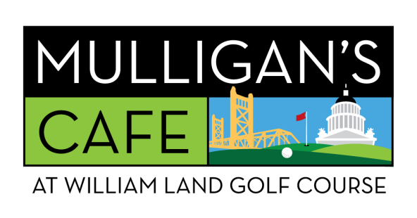
916.808.1208
NEIGHBORHOOD WELCOME!

BREAKFAST
EARLY BIRDIE BREAKFAST - $13.99
WALK IT IN WAFFLES - $7.99
1st TEE BREAKFAST SANDWEDGE - $8.99
BACK 9 BURRITO - $9.99

FAVORITES
MULLIGAN’S GARLIC BUTTER BURGER - $14.99
Sub chicken or veggie patty

BOMB IT BLT - $14.99
MULLIGAN’S JUMBO DOG - $6.99
FLOP SHOT POLISH DOG - $7.99
BUMP AND RUN BRAT DOG - $7.99

SANDWEDGES & SALADS
MULLIGAN’S CLUB SANDWEDGE - $15.99
DUFFER’S DELI SANDWEDGE - $13.99
½ SANDWEDGE W/SOUP OR SALAD - $12.99
MULLIGAN’S GO-BIG SALAD - $10.99
Add Chicken for $2.99
APPETIZERS
MULLIGAN’S PIN SEEKER PIZZA - $13.99
Pepperoni or Tomato Pesto

GARLIC BUTTER BURGER SLIDERS - $10.99
CHICKEN TENDERS - $8.99
CHILI LIME CHICKEN TACOS - $11.99
SURF n’ TURF MAC n’ CHEESE - $13.99
MEXICAN STREET CORN DIP & CHIPS - $10.99
BUCKET of FAIRWAY FRIES - $9.99
Add Garlic or Bacon Bits for $1.99

BUCKET of ALL-STAR ONION RINGS - $11.99

DRINKS & TREATS
JOHN DALY - $8.99
MULLIGAN’S MARY - $9.99
SUNRISE MIMOSA - $10.99
ICED COFFEE - $4.99
FRUIT SMOOTHIE - $9.99

VIC’S ICE CREAM: 1 SCOOP - $4.49 or 2 SCOOPS - $6.49
MULLIGAN’S MILKSHAKE - $8.49
COOKIE SANDWEDGE - $5.49

