Putt out n’ Pick up!
@
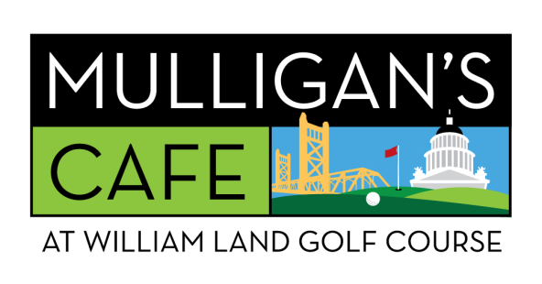
CALL AHEAD TO ORDER FOR PICK UP IMMEDIATELY AFTER YOUR ROUND
(916) 808-1208
PICK UP MENU:
MULLIGAN’S GARLIC BUTTER BURGER - $16.99
FRONT 9 FRENCH DIP - $16.99
KOREAN BEEF FRIED RICE BOWL - $15.99
DELI SANDWEDGE - $14.99
CHICKEN TENDERS BASKET - $12.99
MULLIGAN’S JUMBO DOG - $8.99

